# Name: S. MANSOOR

# REG NO: 192111658

# EXPNO 2:

**DATE:28-04-2023**

# CREATE A VIRTUAL MACHINE WITH 1 VCPU, 2GB RAM AND 15GB STORAGE DISK USING A TYPE 2 VIRTUALIZATION SOFTWARE

**AIM**: To create a virtual machine with 1 CPU, 2gb ram and 15gb storage disk using a type 2 virtualization software

# PROCEDURE:

1. Download VMware workstation and installed as type 2 hypervisor
2. Download Ubuntu or tiny os as iso image file
3. In VMware workstation->create new VM
4. Do the basic configuration settings.
5. Created tiny OS virtual machine
6. Launch the VM

# IMPLEMENTATION:

**STEP 1:**

# DOWLOAD VMWARE WORKSTATION AND INSTALLED AS TYPE 2 HYPERVISOR

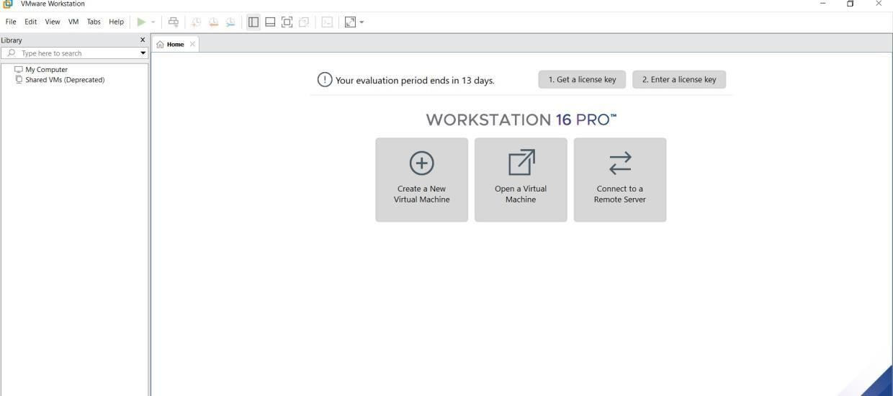

**STEP2: DOWLOAD UBUNTU OR TINY OS AS ISO IMAGE FILE**

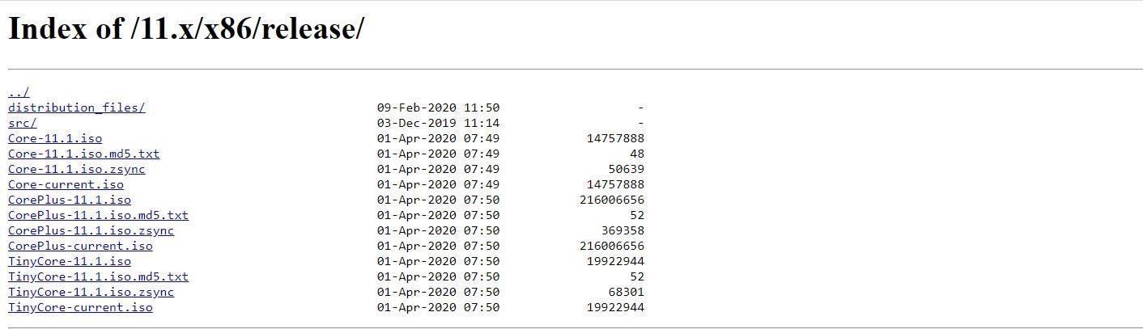

# STEP 3: IN VMWARE WORKSTATION->CREATE NEW VM



**STEP 4: DO THE BASIC CONFIGURATION SETTINGS.**

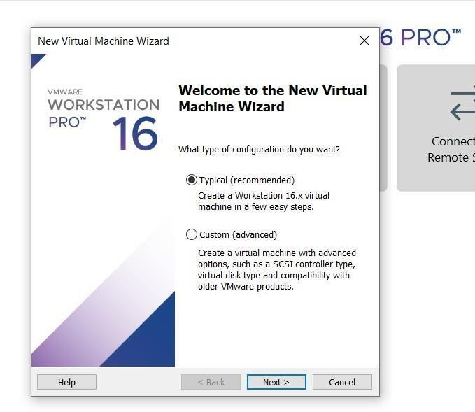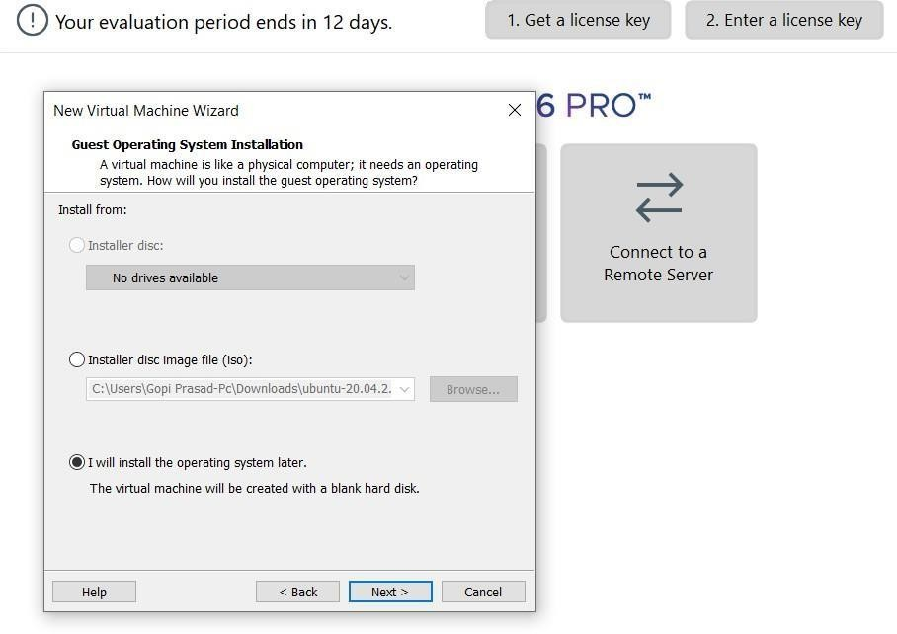

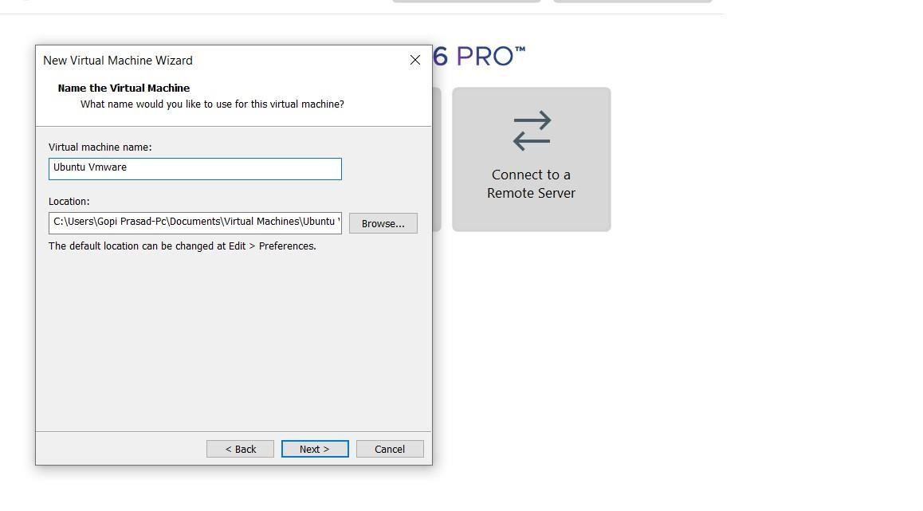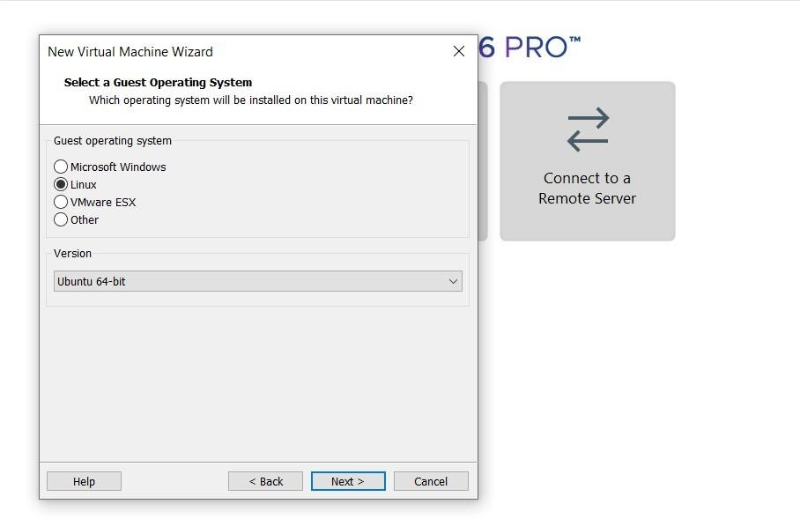

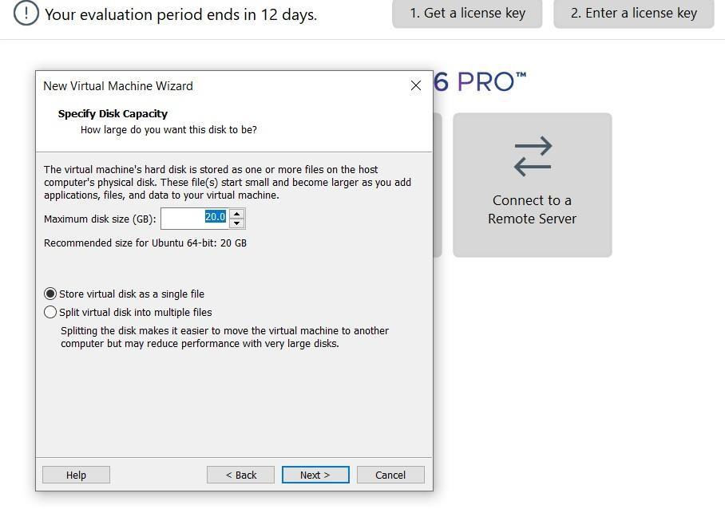

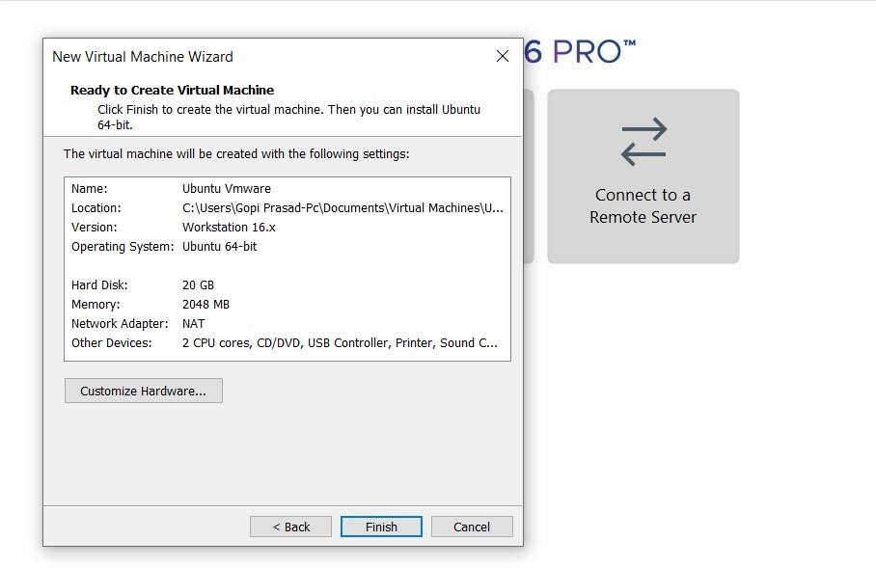

# STEP 4: CREATED TINYOS VIRTUAL MACHINE

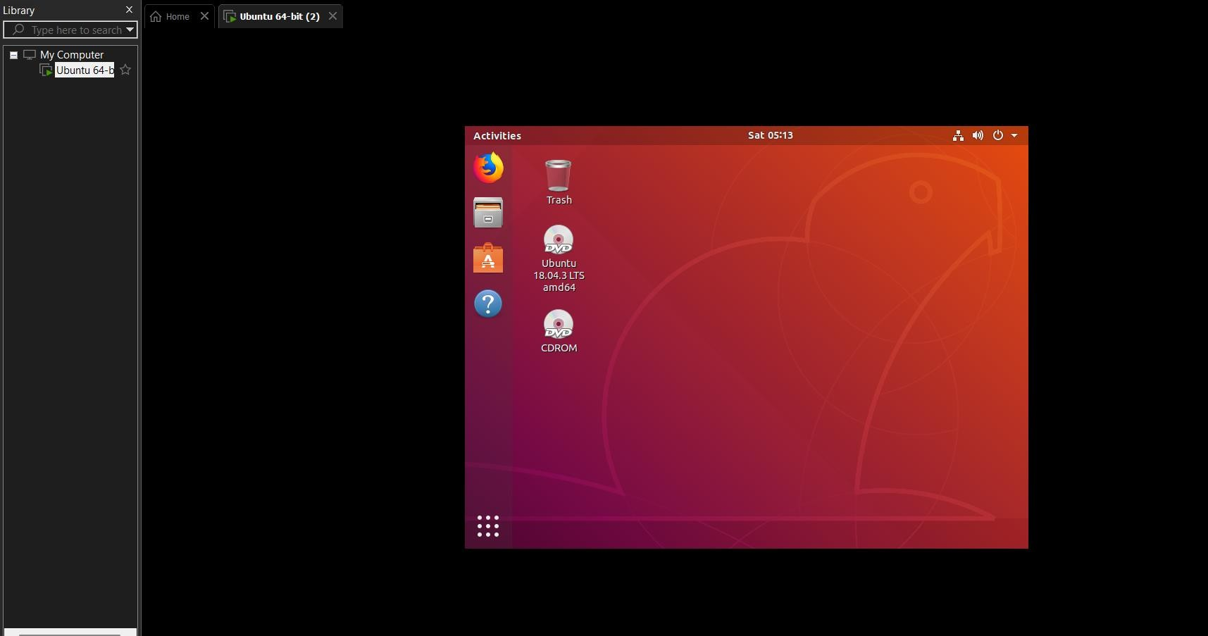**STEP 5: LAUNCH THE VM**

# RESULT:

Hence created a virtual machine with 1 CPU, 2gb ram and 15gb storage disk using a type 2 virtualization software.